
`
School: Coads Green Primary School.
INTRODUCTION / AIMS
Our EYFS Curriculum has been designed to reflect the nature of our school environment, the seasons of the year and the nature around our school. It aims to teach the children how their environment compares to other places, cultures and nature in other parts of the world. Each key text and linked provision are included in the curriculum for very specific reasons and we want to ensure that all children leaving the Foundation Stage are ready to start the KS1 curriculum. Our EYFS curriculum and KS1 curriculum are linked to ensure a smooth transition and to allow learning to be revisited and built upon.

This ambitious Early Year’s curriculum aims to teach all children the skills and knowledge in order that they reach the seventeen Early Learning Goals described in the Early Years Foundation Stage. We teach through a range of teaching methods including child-initiated learning, whole class teaching, group teaching, investigations and problem solving together, and independently. As many activities as possible are play-based; however, there is also a need for direct teacher-led activities to ensure children gain essential knowledge and skills from their teacher. All activities are expertly modelled, and children are given sufficient time, support and resources to repeat and practise them.

Diversity: we have carefully planned our curriculum to include diversity (gender, disability, BAME – Black, Asian and Minority Ethnic) to ensure it is a diverse and inclusive curriculum. Where there are key links, these are highlighted below in yellow

Area of Learning |  | Autumn 1 | Autumn 2 | Spring 1 | Spring 2 | Summer 1 |  | Summer 2
Key Texts | Fiction | 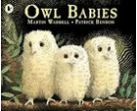  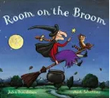 | 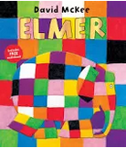  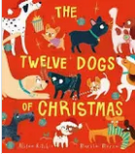 | 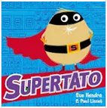  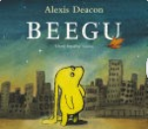 | 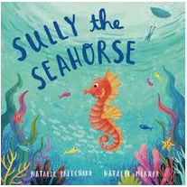  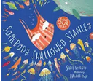 | 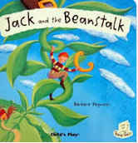  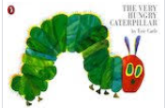 |  | 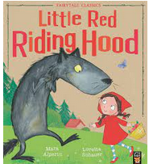  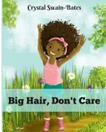
Key Texts | Non-fiction | 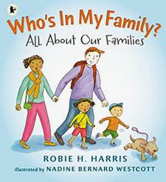 |  |  | 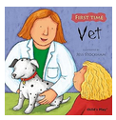 | 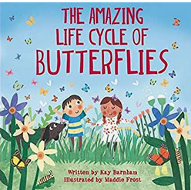
CLL  - Listening, Attention and Understanding  - Speaking |  | - Learn new vocabulary.  - Listen carefully to rhymes and songs, paying attention to how they sound.  - Use new vocabulary in different contexts.  - Use new vocabulary through the day.  - Learn rhymes, poems, and songs.
 |  | Understand how to listen carefully and why listening is important.  Engage in story times. | Ask questions to find out more and to check they understand what has been said to them.  Develop social phrases.  Engage in story times. | Articulate their ideas and thoughts in well-formed sentences.  Connect one idea or action to another using a range of connectives.  Engage in non-fiction books.  Listen to and talk about selected non-fiction to develop a deep familiarity with new knowledge and vocabulary. | Describe events in some detail.  Use talk to help work out problems and organise thinking and activities.  Explain how things work and why they might happen. | Listen to and talk about stories to build familiarity and understanding.  Engage in non-fiction books.  Listen to and talk about selected non-fiction to develop a deep familiarity with new knowledge and vocabulary. |  | Retell stories once they have developed a deep familiarity with the text; some as exact repetition and some in their own words.  Use new vocabulary in different contexts.
 |  | Possible Enhancements:
 |  | Home corner role play area.  Create “family” interest table.  Story telling shelves – Owl Babies. | Story telling shelves – Elmer. | Story telling shelves – Supertato. | Vet’s role play area. | Story telling shelves – Jack and the Beanstalk. |  | Story telling shelves- Little Red Riding Hood; including puppets
PSED  - Building Relationships  - Managing Self  - Self-Regulation |  | NB. These statements have been split for extra focus, but all will apply on an ongoing basis throughout the reception year.
 |  | See themselves as a valuable individual.  Build constructive and respectful relationships.  Express their feelings and consider the feelings of others. |  | Show resilience and perseverance in the face of challenge.  Identify and moderate their own feelings socially and emotionally. |  | Think about the perspectives of others.  Manage their own needs.
 |  | Welcome to school- settling in and getting to know each other.  Expectations for behaviour in school.  Children’s own family and family life.  Looking at children’s differences and preferences.  Making friends with other children.  Exploring feelings of loneliness.  Role Play “home” area. | Exploring the emotion of happiness.  Empathizing with characters from the story. How do they feel?  Who are the people who help us? | Consider how it feels if you don’t succeed at first or achieve your goal?  What happens if children are faced with challenges, they feel afraid?  Discuss relationships with their own family members and special people. | Co-operative role play at the vets.  Taking it in turns with the roles.  Recall and act favourite part of the story.  Create story maps in pairs. | Discuss what Jack did in the story – was it right or wrong?  Talk about feelings of other characters. |  | Recall surprises in our own lives.  Talk about things that we are afraid of.  - Know how to be kind to others.  - Explain how certain behaviours help us show respect to others (such as kindness, helpfulness and honesty).  - Be able to show gratitude for the kind behaviour of others.
PSHE |  | Mental Health and Well-Being  - Families and People Who Care for Me: Understanding that ‘family’ means different things to different people.  NSPCC PANTS | - Caring Friendships: Understanding that there are similarities and differences between everyone and these can be celebrated.  Healthy Eating  - Knowing that different food and drink contains varying amounts of sugar, explaining why it is important to make healthier choices.  (Anti-bullying Week Road Safety Week) | Being Safe  - Understanding the concept privacy, including the right to keep things private and the importance of respecting another person’s right to privacy.  My Body  - Our bodies and boundaries.  (LGBT+ month (Feb) | Online Relationships /Internet Safety and Harms:  - Understanding what being online may look like, the different feelings they can experience online and how to identify adults who can help.  Road Safety  (Internet Safety Day) | Respectful Relationships:  - Recognising what they like and dislike, feeling empowered to make respectful and informed choices.  Mental Well-Being  - Identifying a range of feelings and how these are expressed, including words to describe them and simple strategies for managing feelings.  Sun and Sea Safety |  | Health and Prevention:  - Knowing the importance of basic personal hygiene and understand how hand washing helps to prevent the spread of germs, bacteria and viruses.  Basic First Aid:  - Explaining what first aid is and why it is important.  Recap Sun and Sea Safety
Physical Development  - Gross Motor  - Fine Motor |  | - Develop the overall body strength, co-ordination, balance, and agility needed to engage successfully with future physical education sessions and other physical disciplines including dance, gymnastics, sport, and swimming.  - Develop their small motor skills so that they can use a range of tools competently, safely, and confidently. Suggested tools: pencils for drawing and writing, paintbrushes, scissors, knives, forks, and spoon.  - Use their core muscle strength to achieve a good posture when sitting at a table or sitting on the floor.  - Develop overall body-strength, balance, co-ordination, and agility.
 |  | Further develop the skills they need to manage the school day successfully: lining up and queuing, mealtimes, personal hygiene. | Revise and refine the fundamental movement skills they have already acquired: rolling, crawling, walking, jumping, running, hopping, skipping, climbing. | Further develop and refine a range of ball skills including throwing, catching, kicking, passing, batting, and aiming.  Develop confidence, competence, precision, and accuracy when engaging in activities that involve a ball. | Know and talk about the different factors that support their overall health and wellbeing: regular physical activity, healthy eating, toothbrushing, sensible amounts of ‘screen time’, having a good sleep routine, being a safe pedestrian. | Combine different movements with ease and fluency.  Develop the foundations of a handwriting style which is fast, accurate and efficient. |  | Confidently and safely use a range of large and small apparatus indoors and outside, alone and in a group.
Literacy  - Word Reading  - Writing |  | Read Write Inc school phonics progression map
 |  | Read individual letters by saying the sounds for them. | Blend sounds into words, so that they can read short words made up of known letter-sound correspondences. | Read some letter groups that each represent one sound and say sounds for them.  Read a few common exception words matched to the school’s phonic programme. | Read simple phrases and sentences made up of words with known letter–sound correspondences and, where necessary, a few exception words.  Re-read these books to build up their confidence in word reading, their fluency and their understanding and enjoyment. | Form lower-case and capital letters correctly.  Spell words by identifying the sounds and then writing the sound with letter/s. | Write short sentences with words with known letter-sound correspondences using a capital letter and full stop.  Re-read what they have written to check that it makes sense.
Literacy  - Comprehension and Vocabulary |  | Neli Assessments | Neli for targeted children where needed
 |  | Book Talk linked to key texts. | Book Talk linked to key texts. | Book Talk linked to key texts. | Book Talk linked to key texts. | Book Talk linked to key texts. |  | .  Book Talk linked to key texts.
CLL  - Writing outcomes. |  | Overview of writing progression across the year
 |  | Working on using common consonants and vowels which they can segment for writing simple CVC words. | Working on writing CVC words using a wider range of letters inc. consonant digraphs and double letters e.g. bell, chick | Working on writing a range of CVC words using all the letters and less frequent consonant digraphs and some long vowel phonemes.  Spell red words  Form letters correctly |  | Working on blending adjacent consonants in words and apply this in writing.  Write each letter correctly. |  | Working on segment adjacent consonants on words and apply this in writing.  Spell further red words  Write each letter correctly.
 |  | Possible enhancements for writing
 |  | Write notes and letters and post in box.  Writing notes home to family.  Oral storytelling scribed by the teacher. | Owl Speech and thought bubbles from baby owls.  Writing cards/ notes/ messages.  Halloween speech bubbles  Notes to Father Christmas | Wanted posters for Supertato  Oral storytelling scribed by the adult.  Writing captions to go with the pictures from story.  Speech/thought bubbles for the characters. | Fact files about people who help us.  Write a postcard to and letter to and from friends.  Writing for the role play area prescriptions, messages.  Oral storytelling scribed by the teacher. | Label and write captions.  Recall parts of the story. Speech bubbles and thought bubbles from characters in story.  Imitate, Innovate, Invent  Labelling diagram of plants. |  | Write or dictate own versions of the story.  Making maps.
Maths  - Number  - Numerical Pattern  - Shape and Space |  | Matching.  Sorting & Comparing  Numbers 1, 2, 3, 4, 5, 0  Subitising | Numbers 1, 2, 3, 4, 5, 0  Number bonds recall  Shape  Early doubling  Five Little Speckled Frogs  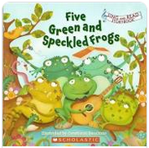 | Numbers 6,7,8,9,10  Place value  Subitising  Shape  Addition / Subtraction | Teen Numbers  Place value  Addition  Subtraction | Number patterns  Addition/Subtraction  Money, time, shape  Halving, doubling, sharing    The Perfect Fit by Naomi Jones |  | Place value  Addition/Subtraction  Money, time, shape  Halving, doubling, sharing
Understanding the World  - People, Culture and Community.  - The Natural World.  - People and places  - Character, setting, event from the past |  | - Understand the effect of changing seasons on the natural world around them  - Describe what they see, hear, and feel whilst outside.
 |  | Talk about members of their immediate family and community.  Name and describe people who are familiar to them.  Changes in seasons- Autumn | Recognise that people have different beliefs and celebrate special times in different ways.  Recognise some similarities and differences between life in this country and life in other countries  Guy Fawkes  The North Pole | Recognise some environments that are different to the one in which they live. | Understand that some places are special to members of their community.  Being a Vet | Explore the natural world around them.  Draw information from a simple map. |  | Comment on images of familiar situations in the past.  Compare and contrast characters from stories, including figures from the past.
Science Links (working scientifically) |  | Evaluate  Use their observations and ideas to suggest answers to questions. | Observe and measure  Observe closely, using simple equipment. | Set up enquiry  Perform simple tests.  Record  Gather and record data to help in answering questions. | Ask Questions  Ask simple Qs and recognise that they can be answered in different ways | Interpret and Report  Identify and classify. Use appropriate scientific language to communicate ideas.  Observe and measure  Observe closely, using simple equipment.
 |  | Plants –  Why do the leaves on trees look different?  Properties and changes of materials–  Seasonal changes –  Signs of Autumn and Winter  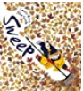  Sweep by Louise Greig  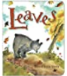  Leaves by David Ezra Stein | Melting ice  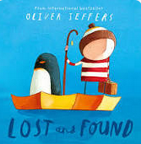  Lost and Found by Oliver Jeffers | Everyday materials –  What makes a good cape?  Exploring materials –  Can you make a boat that floats?  Making a boat to carry a passenger. Making a boat out of plasticine and tin foil | Animals including humans –  What is this part of my body called?  Body parts.  Animals in the aquarium  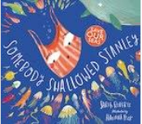  Somebody Swallowed Stanley by Sarah Roberts |  |  | Plants –  What will happen to this seed/bulb?  Planting bean and sunflower seeds.  Animals including humans –  Lifecycles (butterfly/frog).  ‘The Very Hungry Caterpillar’ by Eric Carle.  How to Hide a Lion from Grandma by Helen Stephens  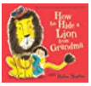
Technology |  | To engage with age appropriate software. | To explore the use of technology as a means of capturing images. | To explore programming using bee bots. | To use technology to promote speaking and listening. | To use technology as a research tool. |  | To produce our own images and videos.
 |  | IWB and I Pads | Use of I-Pad as a camera.  Paint on laptops | Bee-bots on iPads | Using the recordable devices to record. | Using iPads for research. |  | Interactive whiteboard  Class laptops
RE (Understanding Christianity) |  | What is a belief?  • Recall simply what happens at a traditional Christian infant baptism and dedication UW(P&C)  • Recall simply what happens when a baby is welcomed into a religion other than Christianity. | Recall simply what happens at a traditional Christian festival (Christmas) | • Retell stories, talking about what they say about the world, God, human beings CAL (U)  • Say how and when Christians like to thank their Creator UW(P&C) | Recognise and retell stories connected with celebration of Easter UW(P&C)  • Say why Easter is a special time for Christians UW(P&C) | • Recognise that some religious people have places which have special meaning for them UW(P&C)  • Talk about the things that are special and valued in a place of worship UW(P&C) |  | Begin to recognise that for Christians, Muslims or Jews, these special things link to beliefs about God CAL(U)  • Talk about some religious stories CAL(U)  • Recognise some religious words, e.g. about God CAL(S)  • Identify a sacred text e.g. Bible, Torah UW(TW)
Expressive Arts and Design  - Creating with Materials  - Being Imaginative and Expressive |  | - Explore, use, and refine a variety of artistic effects to express their ideas and feelings.  - Explore and engage in music making and dance, performing solo or in groups.
 |  | Develop storylines in their pretend play. | Sing in a group or on their own, increasingly matching the pitch and following the melody. | Return to and build on their previous learning, refining ideas and developing their ability to represent them | Create collaboratively sharing ideas, resources, and skills. | Listen attentively, move to and talk about music, expressing their feelings and responses. |  | Watch and talk about dance and performance art, expressing their feelings and responses
 |  | Possible Enhancements:
 |  | Basic mark-making using one colour.  Naming and using primary colours.  Experimenting with variety of tools. | Firework dances.  Painting simple shapes and filling with colour. | Wild Tribe – creating stick ‘superheroes.’  Informal colour mixing Naming, mixing and using secondary colours. | Exploring working with paint on different surfaces and in different ways Painting without tools.  Aquarium pictures | Still life drawings/paintings of plants and flowers.  Beginning to predict the end result when mixing colouring. |  | Mixing colour more purposefully to make a waterscape and then adding more detail to paintings in a number of sessions.
D and T (joining) |  | Basic Level Joins glue stick, PVA glue with a glue brush, PVA glue with a spreader, make glue from flour |  | Mid-Level Joins masking tape, sticky tape, folding paper and card, elastic band, sticky tack, a paper clip, a stapler |  | High Level Joins hole punch (single and double) split pins, treasury tags, stitching
Music |  | Charanga – Hey You  Hip Hop  /Hands, Feet Heart | Charanga – Rhythm in the Way we Walk  Reggae  /Ho Ho Ho | Charanga – In the Groove  Blues  /I Wanna Play in a Band | Charanga – Round and Round Bossa Nova  / Zootime | Charanga – Your Imagination  Pop  /Friendship Song |  | Charanga – Reflect, Rewind and Replay  Classical
Off Site Enrichment
Internal Enrichment |  | Wild Tribe | Wild Tribe | Wild Tribe | Wild Tribe | Wild Tribe |  | Wild Tribe

